PRESS RELEASE

Release date: 1st October 2014 at 06:00
Media Contact: Dr Joost van Middendorp
Contact Details: 01296 316783 or email Joost.vanMiddendorp@buckshealthcare.nhs.uk

‘Top 10’ Research Priorities for Spinal Cord Injury Announced

A ground-breaking survey has identified a ‘Top 10’ of priorities for researchers to investigate that will improve the quality of life, care and treatment for people living with a Spinal Cord Injury, including those with Cauda Equina Syndrome and Transverse Myelitis. The Number 1 priority identified by the survey relates to the effectiveness of activity-based rehabilitation.

Every year in the UK over 1,000 people experience a Spinal Cord Injury (SCI) and there are an estimated 40,000 spinal cord injured people in the UK alone. Spinal cord injury often causes paralysis and can also affect many other aspects of a person’s health – a SCI is life changing condition and can happen to anyone, at any time.

Initiated by the Stoke Mandeville Spinal Foundation, independently led by the James Lind Alliance and funded by the Oxford Biomedical Research Centre, the Spinal Cord Injury Priority Setting Partnership (SCI-PSP) was made up of patient and carer representatives and healthcare professionals. Its objective was to identify and prioritise the most important research questions for anyone with an interest in Spinal Cord Injury – thus enabling researchers to address topics in the future that are demonstrably important to the wider SCI community.

Paul Smith, Chief Executive Officer of the Spinal Injuries Association, is delighted with the outcome of the SCI-PSP. “The way that anyone with an interest in spinal cord injury has been able to contribute to identifying future research priorities is just fantastic and has produced some really interesting results” he said. “I look forward to seeing future research address these issues, which are demonstrably important to the spinal cord injury community”.

The Top 3 research priorities identified by the survey were:

- Does activity based rehabilitation, including functional electrical stimulation coupled with physical activity and hydrotherapy, improve outcomes such as muscle function and neuroplasticity after spinal cord injury?
- Does stem cell therapy result in better outcomes after spinal cord injury and does this depend on the type of injury (e.g. acute or chronic; complete or incomplete)?
- Does the provision of care packages in the community, including physiotherapy, after discharge from hospital improve the health and wellbeing of people living with spinal cord injury?
Other areas identified in the ‘Top 10’ for future research included bladder and bowel management, the impact of specialist rehabilitation services on health and wellbeing, the effects of ageing after a spinal cord injury on the development of complications and whether early diagnosis and treatment led to improved outcomes for people with Cauda Equina Syndrome or Transverse Myelitis.

A two-stage survey process was used to firstly gather possible research questions and then to rank them in order of priority. Both surveys were open to anyone with an interest in spinal cord injury, be they people living with a spinal cord injury, their partners, carers, clinicians or simply people with a strong interest in the field of SCI. Hundreds of people took part and this broad perspective generated some brilliant responses and clearly showed how much there is still to do in the field of spinal injury research.

The last stage was a Final Prioritisation Workshop, where an outstanding group of twenty five individuals with a SCI, representatives of service user organisations, carers and healthcare professionals came together to consider and discuss the outcomes from the second survey. This was an inspiring day of discussion and debate which ultimately validated and agreed the ‘Top 10’ research priorities.

Dr Joost Van Middendorp, Research Director at the Stoke Mandeville Spinal Foundation and the instigator of this unique project commented that “Following a comprehensive, rigorous, and inclusive process, with equal participation from individuals with SCI, carers, and health professionals, the SCI research agenda has been defined by people to whom it matters most and this should now inform the scope and future activities of funders and researchers alike.”

Further information about the SCI-PSP including details of the methodology used and details of the full ‘Top 10’ research priorities can be found on the website at www.sci-psp.org.uk

Notes for Editor:

Research on the effects of treatments often overlooks the shared priorities of patients, carers and clinicians. The pharmaceutical industry and academia play essential roles in developing and testing new treatments, but their priorities are not necessarily the same as those of patients, carers and clinicians. Many areas of potentially important research are therefore neglected. The James Lind Alliance exists to address this imbalance.

The JLA is a non-profit making initiative which brings patients, carers and clinicians (healthcare professionals) together in Priority Setting Partnerships to identify and prioritise the unanswered questions about treatments that they agree are most important. Priority Setting Partnerships focus on a particular condition or healthcare issue and work to identify and prioritise unanswered questions about treatment, for research. These are also known as treatment uncertainties.

The JLA has worked with a wide range of Priority Setting Partnerships including for asthma, urinary incontinence, vitiligo, prostate cancer, type 1 diabetes, schizophrenia, eczema, stroke, sight loss & vision, cleft lip & palate, dementia, preterm birth, tinnitus, Lyme disease, pressure ulcers and acne.

More information about the James Lind Alliance can be found on their website at: www.jla.nihr.ac.uk

The SCI-PSP is independently led by the James Lind Alliance and managed by the following organisations:

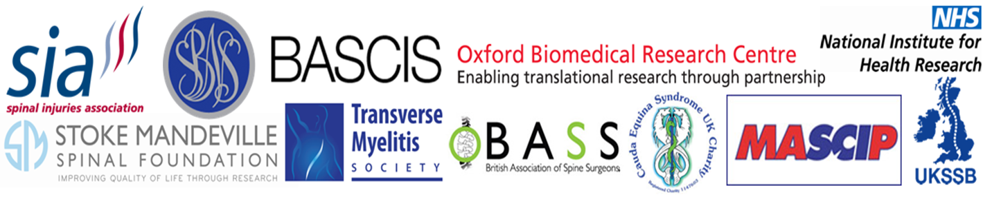

Attendees of the Final Prioritisation Workshop at Stoke Mandeville:

