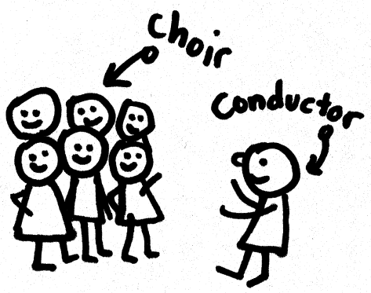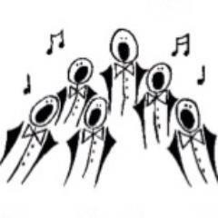
Lions Club of Kenton
Charity Concert Harrow Apollo Male Choir
In aid of

The Transverse Myelitis Society
Vivien’s neurological condition

Saturday 15th June, 2019 at 7.30pm
Pinner Methodist Church, Love Lane, Pinner, HA5 3EE
You are warmly invited to Lions Club of Kenton’s Summer Fundraiser Concert where the Apollo Choir will be singing many well-known songs, including some from West End shows.
Light refreshments will be provided during the interval.
Tickets £10. No seats can be reserved so an early arrival is advised. If you are unable to attend a donation would be most welcome.

Free parking is available in the Pinner main car park signposted to the Pinn Medical Centre by the Marks & Spencer Food Store, Pinner Village.

Contact Vivien Raggett at raggett@talktalk.net or 0208 866 9477 or 07951 722830

